Exercise 1: Control Structures

Tables:
CREATE TABLE Customers (
CustomerID int PRIMARY KEY,
Name VARCHAR(10),
Age int,
Balance int,
IsVIP VARCHAR(5) DEFAULT 'FALSE'
);
CREATE TABLE Loans (
LoanID int PRIMARY KEY,
CustomerID int,
InterestRate int,
DueInDays int, -- Simple numeric instead of DATE
FOREIGN KEY (CustomerID) REFERENCES Customers(CustomerID)
);

INSERT INTO Customers VALUES (1, 'Alice', 65, 12000, 'FALSE');
INSERT INTO Customers VALUES (2, 'Bob', 45, 8000, 'FALSE');
INSERT INTO Customers VALUES (3, 'Charlie', 70, 11000, 'FALSE');
INSERT INTO Customers VALUES (4, 'David', 30, 9500, 'FALSE');

INSERT INTO Loans VALUES (101, 1, 10.5, 10); -- Due in 10 days
INSERT INTO Loans VALUES (102, 2, 12.0, 40); -- Due in 40 days
INSERT INTO Loans VALUES (103, 3, 9.0, 25); -- Due in 25 days
INSERT INTO Loans VALUES (104, 4, 11.0, 5); -- Due in 5 days

Select * from Customers;
select * from Loans;

Initial Tables:
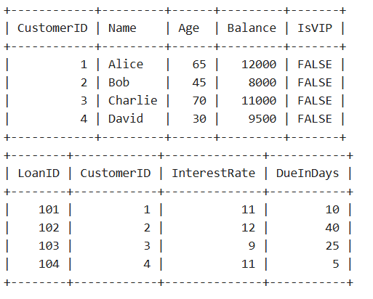
Scenario 1: The bank wants to apply a discount to loan interest rates for customers above 60 years old.
  - Question: Write a PL/SQL block that loops through all customers, checks their age, and if they are above 60, apply a 1% discount to their current loan interest rates.

Answer:
BEGIN
FOR cust IN (SELECT CustomerID, Age FROM Customers) LOOP
IF cust.Age > 60 THEN
UPDATE Loans
SET InterestRate = InterestRate - 1
WHERE CustomerID = cust.CustomerID;
END IF;
END LOOP;
COMMIT;
END;
output(tables after the scenario 1):
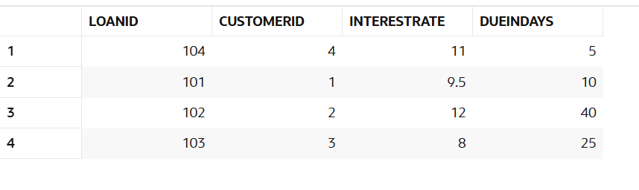

Scenario 2: A customer can be promoted to VIP status based on their balance.
  - Question: Write a PL/SQL block that iterates through all customers and sets a flag IsVIP to TRUE for those with a balance over $10,000.

Answer:
BEGIN
FOR cust IN (SELECT CustomerID, Balance FROM Customers) LOOP
IF cust.Balance > 10000 THEN
UPDATE Customers
SET IsVIP = 'TRUE'
WHERE CustomerID = cust.CustomerID;
END IF;
END LOOP;
COMMIT;
END;
output(tables after the scenario 2):
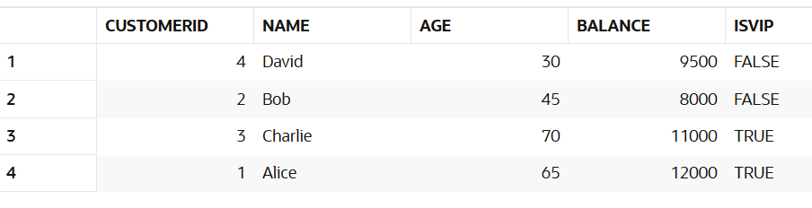

Scenario 3: The bank wants to send reminders to customers whose loans are due within the next 30 days.
  - Question: Write a PL/SQL block that fetches all loans due in the next 30 days and prints a reminder message for each customer.

Answer:
BEGIN
FOR loan IN (SELECT LoanID, CustomerID, DueDate FROM Loans
WHERE DueDate <= SYSDATE + 30) LOOP
DBMS_OUTPUT.PUT_LINE('Reminder: Loan ' || loan.LoanID ||
' for Customer ' || loan.CustomerID ||
' is due on ' || TO_CHAR(loan.DueDate, 'DD-MON-YYYY'));
END LOOP;
END;
Output:
